Name: ____________________
Class: ________________( )
2024-2025
S6 MATH CP
PAPER II

CUHKFAA CHAN CHUN HA SECONDARY SCHOOL
2024-2025 Secondary Six First Term Examination

MATHEMATICS Compulsory Part
PAPER 2

07/11/2024

11:05 am – 12:20 pm (1¼ hours)

INSTRUCTIONS
- Read carefully the instructions on the Answer Sheet. After the announcement of the start of the examination, you should first write your Name Class and Class Number and insert the information required in the spaces provided. No extra time will be given for writing your Name, Class and Class number after the ‘Time is up’ announcement.
- When told to open this book, you should check that all questions are there. Look for the words ‘END OF PAPER’ after the last question.
- All questions carry equal marks.
- ANSWER ALL QUESTIONS. You are advised to use an HB pencil to mark all the answers on the Answer Sheet, so that wrong marks can be completely erased with a clean rubber. You must mark the answer clearly; otherwise you will lose marks if the answers cannot be captured.
- You should mark only ONE answer for each question. If you mark more than one answer, you will receive NO MARKS for that question.
- No marks will be deducted for wrong answers.
There are 30 questions in Section A and 15 questions in Section B.
The diagrams in this paper are not necessarily drawn to scale.
Choose the best answer for each question.

Section A
1. x² − xy − 3y − 9 =
A. (x + 3)(x − y − 3).
B. (x + 3)(x + y − 3).
C. (x − 3)(x − y + 3).
D. (x − 3)(x + y + 3).

2. 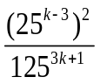=
A. 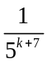.
B. 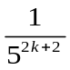.
C. 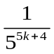.
D. 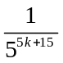.

3. It is given that (2x + 1)² + 2hx ≡ (4x − 1)(x + h) + k(x − 1), where h and k are constants. Find k.
A. 6
B. 5
C. −6
D. −7

4. Let m be a constant. If (x + 2m)(x − 3m) = (2x + m)(x − 3m), then
A. x = m or x = 3m.
B. x = −m.
C. x = m.
D. x = −m or x = 3m.

5. If 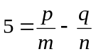, then n =
A. 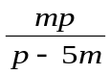.
B. 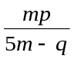.
C. 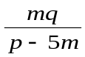.
D. 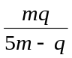.

6. 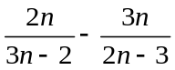=
A. 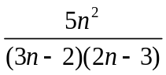.
B. 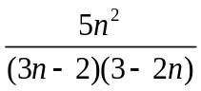.
C. 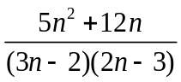.
D. 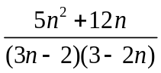.

7. If y = 3.141 (correct to 3 decimal places), find the range of values of y.
A. 3.1405 ≤ y < 3.1415
B. 3.140 ≤ y < 3.142
C. 3.1405 < y ≤ 3.1415
D. 3.140 < y ≤ 3.142

8. Let g(x) = (x − 2a)(x − 5) + 3b, where a and b are constants. If g(0) = g(6) = 2, find b.
A. 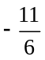
B. 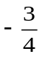
C. 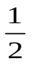
D. −1

9. Let q(x) be a polynomial. When q(x) is divided by x + 2, the remainder is −8. If q(x) is divisible by
x − 2, find the remainder when q(x) is divided by x² − 4.
A. 2x + 4
B. 2x − 4
C. −2x + 4
D. −2x − 4
10. Let G be the graph of y = (x − c)(1 − cx), where c < −1. Which of the following statements about G are true?
I. G has two x-intercepts.
II. The y-intercept of G is negative.
III. G opens upwards.
A. I and II only
B. I and III only
C. II and III only
D. I, II and III

11. A sum of $88 000 is deposited at an interest rate of 9% per annum for 2 years, compounded monthly. Find the interest correct to the nearest dollar.
A. $15 840
B. $16 553
C. $17 284
D. $26 932

12. In the figure, the 1st pattern consists of 3 dots. For any positive integer n, the (n + 1)th pattern is formed by adding (2n + 5) dots to the nth pattern. Find the number of dots in the 8th pattern.
…
A. 75
B. 94
C. 104
D. 115

13. The radius of a solid hemisphere X and the base radius of a solid right circular cone Y are equal. If the slant height of Y is equal to 1.5 times its base diameter, find the ratio of the total surface area of X to the total surface area of Y.
A. 1 : 1
B. 2 : 3
C. 3 : 4
D. 4 : 3

14. In the figure, M and N are points lying on PQ and QR respectively such that PM : MQ = 6 : 5 and QN : NR = 2 : 5. If the area of the quadrilateral MNRP is 67 cm², then the area of ΔMNQ is
N
M
P
R
Q
A. 10 cm².
B. 11 cm².
C. 12 cm².
D. 13 cm².

15. In the figure, ABCD is a rectangle. ECF is a straight line such that ∠BEC = ∠CFD = 90°. It is given that CE < CF. If BE = 160 cm, EF = 116 cm and DF = 18 cm, then the perimeter of the rectangle ABCD is
B
C
F
A
D
E
A. 356 cm.
B. 480 cm.
C. 492 cm.
D. 588 cm.

16. If ABCDEF is a regular 6-sided polygon, which of the following are true?
I. AC // FD
II. AE = DB
III. ∠ABC = 2∠CBD
A. I and II only
B. I and III only
C. II and III only
D. I, II and III
17. In the figure, PQRST is a circle. If PR = QS, ∠QSP = 42° and ∠QSR = 11°, then ∠PTS =
P
R
S
Q
T
A. 53°.
B. 84°.
C. 85°.
D. 95°.

18. The coordinates of the point A are (−4, 2). A is rotated clockwise about the origin through 270° to the point B. B is then reflected with respect to the x-axis to the point C. Find the y-coordinate of C.
A. −4
B. −2
C. 2
D. 4

19. In the figure, 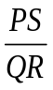=
P
R
S
Q
φ
θ
A. 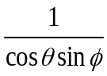.
B. 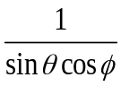.
C. 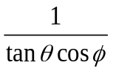.
D. 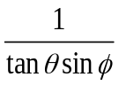.

20. Let u and v be constants. The figure shows the graph of the straight line ux + vy = 4. Which of the following is/are true?
x
y
O
2
−2
I. u > 0
II. v > −2
III. u + v > 0
A. I and II only
B. I and III only
C. II and III only
D. I, II and III

21. The rectangular coordinates of the point A are 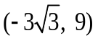. If A is rotated anti-clockwise about the origin through 90°, then the polar coordinates of its image are
A. 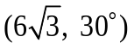.
B. 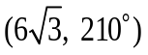.
C. 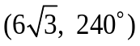.
D. 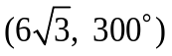.

22. The straight line 4x + 7y + 56 = 0 cuts the x-axis and the y-axis at the points P and Q respectively. Let M be a moving point in the rectangular coordinate plane such that M is equidistant from P and Q. Find the equation of the locus of M.
A. 7x − 4y − 33 = 0
B. 7x − 4y + 33 = 0
C. x² + y² + 28x − 64 = 0
D. x² + y² + 16y − 196 = 0

23. The coordinates of the points D, E and F are (16, 1), (0, 31) and (23, 8) respectively. Let C be the circle which passes through D, E and F. Which of the following is NOT true?
A. DE is a diameter of C.
B. The centre of C lies on the straight line 2x − y = 0.
C. The point (19, 3) lies inside C.
D. The distance from the point F to the line segment DE is less than 9.5.

24. It is given that the straight line L and the circle x² + y² − 12x − 10y + 25 = 0 intersect at the points A and B. The slope of L is 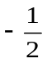. Let (p, q) be the coordinates of the mid-point of AB. Which of the following must be true?
A. p + 2q − 16 = 0
B. 2p − q + 7 = 0
C. 2p − q − 7 = 0
D. p + 2q + 16 = 0

25. The figure shows a parallelogram. Which of the following must be true?
p
s
q
r
I. p + q = 180°
II. s = p + 180°
III. r − p = 270°
A. I and II only
B. I and III only
C. II and III only
D. I, II and III

26. The equation of the circles C₁ and C₂ are 2x² + 2y² − 4x + 36y − 425 = 0 and
x² + y² − 18x + 6y − 10 = 0 respectively. Which of the following is/are true?
I. The centre of C₁ lies on C₂.
II. The radii of C₁ and C₂ are equal.
III. C₁ and C₂ intersect at two distinct points.
A. I only
B. II only
C. I and II only
D. I and III only

27. Let A be the point of intersection of the straight lines 3x + 4y − 7 = 0 and 3x − 4y + 7 = 0. If P is a moving point on the rectangular coordinate plane such that the distance between P and A is 10, then the locus of P is a
A. circle.
B. triangle.
C. quadrilateral.
D. regular hexagon.

28. Two numbers are randomly drawn at the same time from five cards numbered 2, 3, 5, 7 and 9 respectively. Find the probability that the product of the numbers drawn is less than 35.
A. 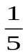
B. 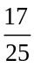
C. 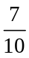
D. 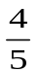
29. The box-and-whisker diagram below shows the distribution of the ages of some footballers of a team. Find the inter-quartile range of the distribution.
17
25
29
35
37
Age
A. 8
B. 10
C. 12
D. 20

30. Consider the following positive integers:
4 | 5 | 7 | 7 | 8 | a | a | b | b | b
It is given that both the mean and the median of the above positive integers are 7. Which of the following must be true?
I. The mode of the above positive integers is b.
II. The least possible range of the above positive integers is 5.
III. The greatest possible variance of the above positive integers is 9.4.
A. I and II only
B. I and III only
C. II and III only
D. I, II and III
Section B

31. 13 × 16¹³ + 17 × 16¹² + 16³ + 17 =
A. D110000000021₁₆.
B. E100000000111₁₆.
C. D1100000000021₁₆.
D. E1000000001011₁₆.

32. If log₃ y = 3x − 2 and (log₃ y)² = 11x² − 28, then log₉ y =
A. 2 or −8.
B. 2 or −13.
C. 4 or −26.
D. 8 or −52.

33. The graph in the figure shows the linear relation between log₃ x and log₃ y. Which of the following must be true?
O
1
log₃ x
−3
log₃ y
A. xy³ = 27
B. x³y = 27
C. 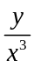= 27
D. 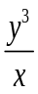= 27

34. The L.C.M. of x³y⁴z², xy⁴z³ and x⁵y²z is
A. x⁵y⁴z³.
B. x⁵yz³.
C. xy²z².
D. xy²z.

35. If a > 0, which of the following are arithmetic sequences?
I. log a⁻², log a⁴, log a¹⁰
II. 3 − 4a, 4 − 3a, 5 − 2a
III. cos (270 − a)°, cos 270°, cos (270 + a)°
A. I and II only
B. I and III only
C. II and III only
D. I, II and III

36. The sum of the 2nd term and the 4th term of a geometric sequence is 312 while the sum of the 5th term and the 7th term of the sequence is 1053. Find the 8th term of the sequence.
A. 729
B. 1093.5
C. 1640.25
D. 2460.375

37. Let z = 8 + 3ai¹⁷ + 14i²³ − 10i²⁶ − ai²⁸, where a is a real number. If the sum of the real part and the imaginary part of z is 38, then the imaginary part of z is
A. 1.
B. 17.
C. 37.
D. 49.

38. In the figure, ABCDEFGH is a cube. If x is the angle between ΔABF and ΔADF while y is the angle between ΔABF and ΔBDF, then
E
A
B
F
D
C
G
H
A. x > 75° and y < 55°.
B. x < 75° and y > 55°.
C. x < 75° and y < 55°.
D. x > 75° and y > 55°.

39. Consider the following system of inequalities:
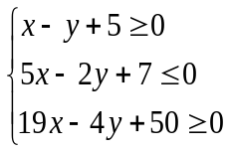
Let R be the region which represents the solution of the above system of inequalities. If (x, y) is a point lying in R, then the greatest value of 10x + 6y is
A. 46.
B. 26.
C. - 2.
D. - 79.

40. In the figure, AE and CF are the tangents to the circle ABCD at A and C respectively. It is given that BD // CF, ∠EAB = 132° and ∠ABD = 38°. Find ∠BDC.
E
A
B
F
D
C
A. 38°
B. 45°
C. 47°
D. 52°

41. Let m be a constant. Find the range of values of m such that x² − mx − m + 3 > 0 for any real number x.
A. −6 < m < 2
B. −2 < m < 6
C. m < −6 or m > 2
D. m < −2 or m > 6

42. If the straight line x − y + 8 = 0 and the circle (x − 8)² + (y − 6)² = 100 intersect at the points A and B, then the equation of the circle with AB as a diameter is
A. x² + y² − 6x − 22y − 70 = 0.
B. x² + y² − 6x − 22y + 80 = 0.
C. x² + y² − 6x − 22y + 30 = 0.
D. x² + y² − 16x − 12y = 0.
43. The variance of five numbers 3a + 5, 3a + 9, 3a + 11, 3a + 13 and 3a + 17 is
A. 4.
B. 8.
C. 16.
D. 3a + 16.

44. A box contains 3 black cards, 3 blue cards and 2 green cards. Amy and Billy take turns to draw one card randomly from the box with replacement until one of them draws a black card or a blue card. Amy draws a card first. Find the probability that Billy draws a black card.
A. 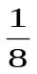
B. 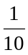
C. 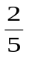
D. 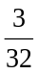

45. If the first three digits of an eight-digit password are formed by a permutation of 1, 3 and 7, while the last five digits are formed by a permutation of 0, 2, 4, 6 and 8, how many different passwords can be formed?
A. 56
B. 126
C. 720
D. 1440

END OF PAPER

